Tyler Butler

10/19/18

IT Analysis

Midterm Project

**Part #1:**

**System Vision Document**

On the Spot Courier Services

**Problem Description:**

In the courier business one thing stands true over all. The fastest courier gets the most business. This is exactly what Bill Wiley saw when he has met with many different companies that had a need for same-day delivery. With a high-demand for same-day deliveries Bill saw an opportunity to start a new courier business to help fill this gap, thus On the Spot Courier Services was created. It wasn’t long after the business was created, that mobile phone orders were becoming obsolete and these clients wanted an interactive web-site to place orders and deliveries. As the demand for deliveries grew so did the need for extra personnel, Bill had hired an extra person to handle deliveries but now faces a problem of having to have a central warehouse location.

It is recommended that this business invest in a web-site to allow clients to seamlessly order and confirm deliveries with On the Spot Courier. It is also recommended that this business creates a warehouse system to help organize and manage all warehouse orders.

**System Capabilities:**

The new system should be capable of:

* Collecting Client information (Business name, phone number, ETC.)
* Collecting Package information (Weight, Delivery location, ETC.)
* Scheduling order of deliveries
* Taking online payments for delivery services
* Being queried for various information (Client name, phone number, ETC.)
* Handling/managing warehouse orders
* Managing warehouse package locations

**Business Benefits:**

It is anticipated that the deployment of a newly created website and warehouse management system will provide the following business benefits:

* Improved delivery management
* Increase in amount of deliveries
* Increased customer satisfaction with ordering deliveries
* Easier management of payment
* Updated technology
* Improved management of warehouse

**Part #2:**

**List at least three stakeholders:**

* Wayne Johansen
* Nick Johansen
* Geocaching Enthusiasts

**List at least ten functional requirements, as well as at least three usability, reliability, security, and performance requirements each for the system:**

**Functional Requirements:**

* Contact Forms
* Information Forms
* Web Integration
* Connection via Wi-Fi
* Connection via Cellular Data
* Graphing Systems
* Cache Listing
* GPS Integration
* Found Cache Listing
* Database of all Caches
* User-Login
* Profiles

**Usability Requirements:**

* Multi-Language Support
* Mobile Device Integration
* Simple UI
* Logo Displayed

**Reliability Requirements:**

* 24/7 support for contact us page
* Less than a half-hour downtime for system
* 3-hour Recovery Rate from Complete System Outage

**Security Requirements:**

* Password Verification
* ID Verification
* Secure HTTP Communication

**Performance Requirements:**

* Support for 300+ Simultaneous Client Sessions
* .3 Response rate for all button presses
* 40 mb/s Speed for the system

**List at least five sample questions you would ask of the stakeholders in the system when gathering requirements for the system:**

* How are Caches input into the system?
* How many clients will be using the system at once?
* What kind of connections are going to be allowed for this system?
* What database structuring will this system use?
* Will this system support international Geo-Caching?
* What verification methods will be used to guarantee accurate caching placements?
* How often will the system check for “Found” Geo-Caches?

**Part #3:**

**Define at least three actors for your use cases**

* Customer
* Medical Personnel
* SMD Management

**Define at least five use cases for the system. These should be in a simple actor->verb form (e.g., actor 1 does the following in the system) at a granular level.**

* Customer Monitors Glucose Level
* Customer communicates with medical personnel
* Medical Personnel monitors customer glucose levels
* SMD management pulls data from database
* Medical Personnel looks up customer information
* SMD management deploys an update to system

**Include a use case diagram for your actors and use cases.**

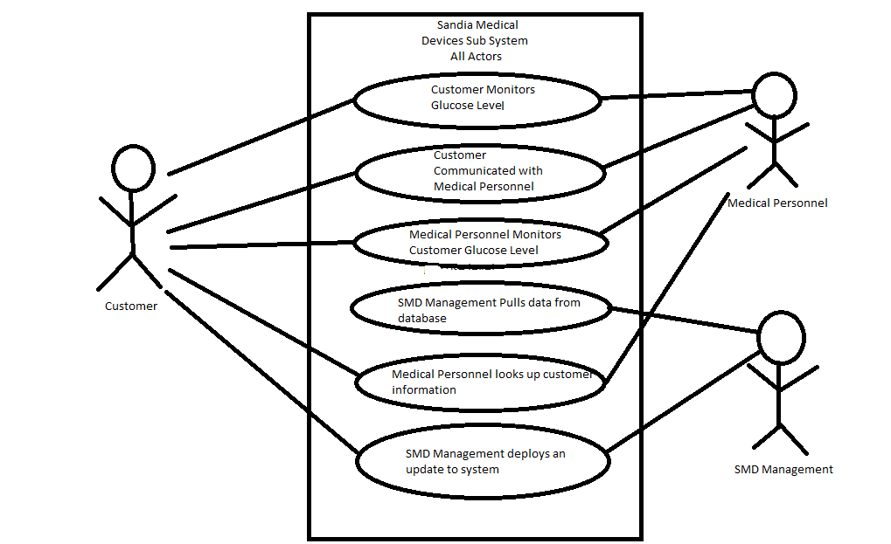

**Write a fully developed use case of what you consider to be the most important use case using the model template in Figure 5-2.**

|  |  |  |
| --- | --- | --- |
| **Use Case Name:** | Monitor Glucose Levels | |
| **Scenario:** | Read glucose data from application | |
| **Triggering Event:** | Customer wants read glucose data from the monitoring application | |
| **Brief Description:** | Customer monitors glucose levels by opening the application and scrolling through the data charts that contain his glucose level information. | |
| **Actors:** | Customer | |
| **Related Use Cases:** | Might be invoked by the ‘Medical Personnel monitors customer glucose levels’ Use Case | |
| **Stakeholders:** | Customer, Medical Personnel, SMD Management | |
| **Preconditions:** | System must have glucose level data already stored  Customer information must be validated  System must be able to pull data from the database | |
| **Postconditions:** | Customer glucose levels will be displayed  System will be noted of the monitored activity | |
| **Flow of Activities:** | **Actor** | **System** |
|  | 1. Customer indicates a desire to monitor glucose levels 2. Customer enters in information for validation | * 1. System Prompts User for validating information   2. System inputs information for validation   3. Upon validation, System displays User glucose levels |
| **Exception Conditions:** | 1. There is no glucose data stored for user 2. User information is not valid | |

**Part #4:**

**List at leave five high-level security controls for your subsystems in the project using the broad categories in chapter six of the textbook:**

* “Wayne’s Geocaching System” - Registered Users: This security control would allow the geocaching system to keep un-registered users from using the system maliciously and would make sure that everyone using the system is in the database and can be tracked.
* “Sandia Medical Devices” - Multi-Factor Authentication: This security control would guarantee that the persons who are looking at the glucose levels are indeed the user or the medical personnel. This would avoid any kind of tampering with the data and would also keep malicious users from using/manipulating this data.
* “On the Spot Courier Services” - Completeness Controls: This security control would make sure that all the shipping addresses are correct and fully inputted. This would allow the courier services to have accurate addresses to deliver to and avoid any sort of confusion and wasted time.
* “Sandia Medical Devices” – Access-Control List: This security control would validate that the users trying to perform certain actions have the necessary clearance to do such. This is crucial for this subsystem because you have management users that have access to high-level controls and this security control would stop any malicious hackers from getting access to those controls.
* “Wayne’s Geocaching System” – Authorization: This security control would allow the geocaching system to make sure that certain users are able to place geocaches while others are not. If everyone is authorized to drop off caches it might lead to confusion or even falsified locations. This may potentially be dangerous for users if they try to find these caches in dangerous areas or forbidden areas.

**Also, list specifically what data you would encrypt and what would be the risks and potential consequences if the data were exposed to hackers.**

* The data that I would encrypt would be usernames and passwords. I would encrypt this because it is the root for all other security controls. When a hacker has access to a username and password he can normally override most authorization and access control lists. This is extremely dangerous because with these types of controls ruled obsolete a hacker can run havoc upon a database and system. This type of data in my opinion must be the most secured and most protected out of all data to ensure a safe and healthy system.